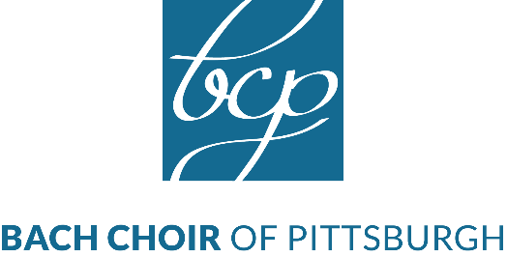
For Immediate Release
April 22, 2019
Contact: Patricia Freedman
412-241-4044
patricia@bachchoirpittsburgh.org

Bach Choir of Pittsburgh presents
The Beatles: The Revolutionaries

In the eight-year span from 1962, when Ringo Starr joined the band, to 1970 when the group disbanded, the Beatles established rock & roll as an art form. Dubbed ‘pop music’s first recording artists,’ they revolutionized pop music culture, the performing industry and the recording industry.

To this day, the Beatles hold the record for the most number-one hits and are ranked as the leading artists of the last 60 years by Billboard Magazine. Their catalog has been re-imagined and recorded in every possible genre and style. The Bach Choir of Pittsburgh takes this opportunity to celebrate this revolutionary body of work.

The Beatles created the powerful social platform that rock music is today, and they used it to respond to what was happening around them socially and politically. During their first US tour in 1964, the group took a stand against racism, refusing to perform in the Gator Bowl in Jacksonville, Florida until the venue management relented and allowed an integrated show. Music journalist Bill DeMain described it as giving ‘pop music a new-found social conscience.

Bach Choir Artistic Director Thomas W. Douglas:
“The 60’s were turbulent times here in the US with the Kennedy assassinations, the Vietnam War, the Civil Rights movement and the assassination of Martin Luther King. The Beatles, from England, were among the first to reflect what was happening through their music. When John Lennon wrote Revolution in 1968 in response to the Vietnam War, he meant a revolution ‘in your head’ to find the road to peace. The Beatles were leading a generation to think differently. I believe, as artists, we have a responsibility to reflect life through our art and to lead our generation.”

Under the baton of maestro Thomas W. Douglas, the 75 voices of the Bach Choir of Pittsburgh will bring the Beatles music alive and transport the audience back to the heady days of 60’s Beatlemania. From I Want to Hold Your Hand (1964) to Hey Jude (1970), the concert will feature selections from every part of the Beatles’s remarkable journey. The program will also include The Long and Winding Road, Eleanor Rigby, Come Together, Hey Jude, Yesterday, Can’t Buy Me Love, Something and many more!
Mr. Smalls Theater in Millvale is the perfect setting – evocative of the nightclubs of Hamburg and Liverpool’s Cavern Club where the Beatles got their start.
Concert information:

Who: The Bach Choir of Pittsburgh
Thomas W. Douglas, Artistic Director

What: The Beatles: The Revolutionaries

When: Saturday, May 4th @ 7:30pm
Sunday, May 5th @ 4:00pm

Where: Mr. Smalls Theater and Funhouse

Tickets are available in advance at ticketmaster.com
And at the door on the day of performance.
Prices range from $12.00-$35.00
More info at www.BachChoirPgh.org
###

